**The website to use as a guide is futenco.com**

**Who We Are**

Smefon Corporate Services ltd is a Nigerian company duly registered under the Companies and Allied Matters act 1990. SCS has business interest in the areas of exports (agricultural commodities), general contracts, renewable energy and feed-stock production (biomass). Our core business focus is providing clean, renewable, sustainable, and affordable energy for various industrial applications and domestic needs. We have built a lean, reliable and responsive business by retaining a flat management structure.

**What We Do**

* SCS is dedicated to providing sustainable and renewable energy with a minimal carbon foot print through a balanced approach of using existing biomass and planted energy crops while protecting the environment. We plan to work with a variety of partners to establish and manage energy crop plantations using idle land thereby helping Nigeria achieve its plan to reduce emissions by 20 per cent in the year 2030. Our ultimate goal is to create a win-win solution for all stakeholders by providing them with clean, renewable, affordable and sustainable biomass energy.

**Our Vision**

To become the provider of choice for clean energy and agro raw materials while having a positive impact on the people, the environment and the communities

**Our Mission**

* To produce power using efficient renewable technologies with minimum carbon footprint
* To add value in the agriculture and energy sector of Nigeria by turning waste to wealth and waste to energy.
* Improve the livelihood of people in our host communities
* Provide clean, sustainable and affordable energy for industrial application and domestic needs
* Create jobs
* Contribute to the mitigation of environmental degradation and global warming through our waste to wealth policy.

**The Team**

SCS is managed by a team of international and domestic consultants with broad experiences in the energy sector, plantation management, organic farming and environmental protection, all committed to manage SCS by international standards. SCS headquarter is in Abuja and field operations are conducted in various locations in Nigeria.

### Products & Services

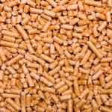Wood Pellets are a type wood fuel that is commonly made from sawdust and other wood waste materials but sometimes also from sources such as whole-tree or tree tops and branches. Pellets are manufactured in several types and grades as fuel for biomass power plants. Wood pellets usually contain no added chemicals as wood naturally contains a substance called lignin that binds wood pellets in their compressed, uniform shape.  
The regular geometry and small size allow for precisely regulated fuel feed into the boiler using either an auger (screw) or pneumatic conveying (using air to transport the pellets). Wood pellets have a consistent high energy, low moisture content (< 10%) and very low ash content allowing a very high combustion efficiency and low air emissions. Their high density permits compact storage and economic transport over long distances. They are either supplied in big bags or can be blown into a storage area on a customer’s premises from a truck or dedicated tanker.  
As a biomass fuel, wood pellets offer the advantages of sustainable energy supply through renewable raw materials. Pellets are environmentally friendly with a low carbon footprint even after transportation. Similar to the wood chips, we use fast growing bamboo from dedicated plantations for production of wood pellets; however we are testing various other energy crops as well in order to create bio diversification and to adjust to local conditions.

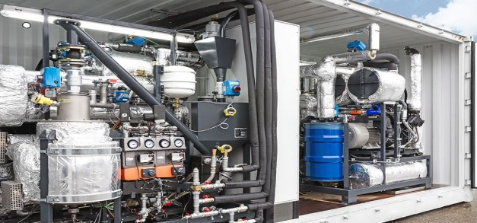 Model XL is the most efficient, reliable and most capable turn-key biomass CHP in the world. With 24/7 Online- Monitoring a 50kW Electric and 120 kW thermal output, XL comes all ready to go in a standard shipping container that can be modified to your design. This plant is incredibly powerful, providing clean, carbon-neutral power where-ever you are. This biomass generator is compact and can be easily transported anywhere in the world. Its modular concept enables individual units to be combined to form a larger plant while maintaining scalable power generation. The power generated can be consumed locally or sold to the electricity grid and can be turned off during off peak demand. The system also provides heating and cooling.

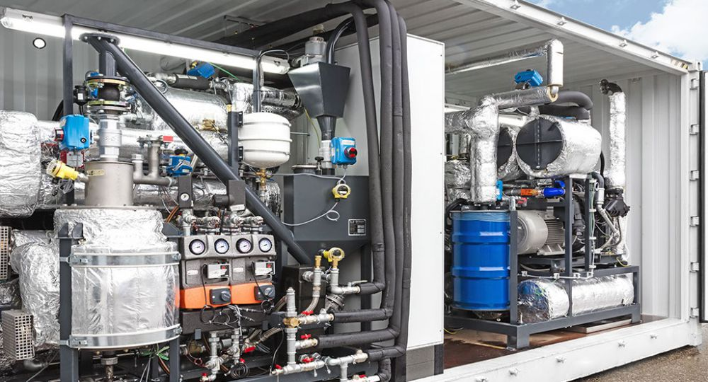

**PROJECT DEVELOPMENT**

Smart project development is important for long-term success. Experts in our in-house planning division specialize in customized large-scale energy installations.

**ENERGY MANAGEMENT**

SCS offers extensive expertise in real-time automation and cloud-based energy management services. We can remotely operate and maintain a large number of power systems around the clock. 24/7 oversight allows us to maximize efficiency while reducing cost. Services can also be managed on-site via a local cloud or the internet. A three-stage redundancy system ensures smooth and uninterrupted operation. It’s the most flexible solution anywhere in the world for power off-takers.

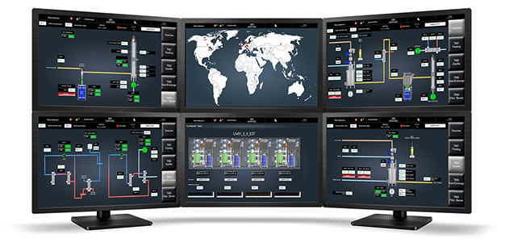

**COMPARATIVE DATA MONITORING**

See how your energy use compares to benchmarks such as traditional energy systems or year-over-year consumption and costs.

**CUSTOMIZED SYSTEM OVERVIEW**

Customize your dashboard to view data and manage your system according to your specific needs.

**VIRTUAL SYSTEM UPGRADES**

Software upgrades are downloaded to your system automatically, so you always have the latest updates.

**LIVE ENERGY CONSUMPTION DATA**

Use any laptop or mobile internet device to monitor energy consumption in real time, from anywhere.

**TRANSPARENT BILLING**

With SCS technology, there’s no waiting until the end of the month to see your costs. Check your expenses at any time to see how you’re tracking within the current cycle.

**THE GREATEST POWER PROBLEM IN NIGERIA TODAY IS NOT TOTALLY POWER GENERATION, BUT AN OUTDATED POWER GRID SYSTEM.**

The security threat to our traditional energy infrastructure is growing every day. A constantly vandalized and outdated grid system can no longer handle the pressure-packed hours of peak demand. Enormous investments will be needed for decades to come to upgrade the overall infrastructure – the kind of investments no one wants to make. We see it as our responsibility to build a more secure and reliable energy system. And that’s what we are doing.

**Sustainability**

[](http://futenco-wp.s3.amazonaws.com/wp-content/uploads/2013/03/Picture1.jpg)

Our sustainability comes from the adaptability of our power plant to use different bio fuels types which are abundantly available within the country. We have been able to setup a systematic fuel supply chain system which is made up of a large number of local suppliers who understand our ‘’no compromise policy. However, we are testing various energy crops and municipal waste while making plans to establish our own dedicated fuel plantation in order to create further bio diversification.

Certification

As a responsible company, we ensure that our operations conform to existing laws. We take the pain to ensure our products and services are certified by the appropriate bodies overseeing the sectors in which we operate. SCS aims to get certifications from local and internationally recognized bodies like

* International Sustainability and Carbon Certification (ISCC) certification of secure, sustainable and eco-friendly biomass and bioenergy
* Forest Stewardship Council (FSC) covering sustainable management of plantations
* Ministry of Environment

Our Commitment

We will work by international standards for sustainability. We will improve the livelihoods of members of our host communities through provision of employment and education. We will protect the environment. We will contribute to mitigation of climate change. We will not engage in deforestation and only use idle land. We will not engage in food versus energy competition. We will engage in making a difference.

Gallery

Videos Pictures

**Contact**

**Email:**

**Department you would like to contact:**

**Message:**

**Send Message**

**Contact Details**

**Address:**

132, Gado Nasko Road, Kubwa - Abuja, Nigeria

**Tel. +2347067764830 +2348176039750**

**Email: smefon@gmail.com**

Name:

Email:

Department you would like to contact:

Service

Other

Message:

© 2017 Smefon.